Create Tagging with ORM Stack

Contents

1. Introduction 3
2. Workflow diagram to deploy the stack 3
3. Create stack for the Tagging 4
4. Plan the Job 7
5. Apply the Job 9
6. Verify in the Console 10

Introduction

This resource provides the Tag Namespace resource in Oracle Cloud Infrastructure Identity service. Creates a new tag namespace in the specified compartment. specify the compartment ID in the request object and also specify a name for the namespace, which must be unique across all namespaces in the tenancy and cannot be changed. The name can contain any ASCII character except the space (_) or period (.). Names are case insensitive. Once a namespace is created, name cannot be changed.

Workflow diagram to deploy the stack

Below diagram shows how the Terraform Artifact are applied in the OCI. While creating a ORM stack, using terraform deliverables Init, Plan and Apply is the flow to provision the resource in the OCI. We can have the deliverables in any of below.
- GitLab/GitHub Repo
- Bitbucket
- Can be in folder/.zip in the local disk
- Object Storage Bucket
- Can be in compartment
- Oracle provided Template

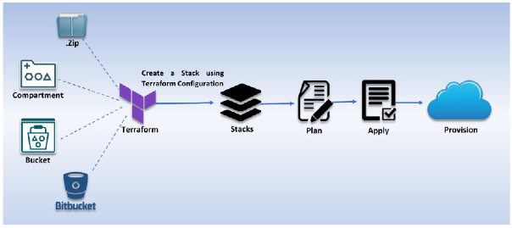
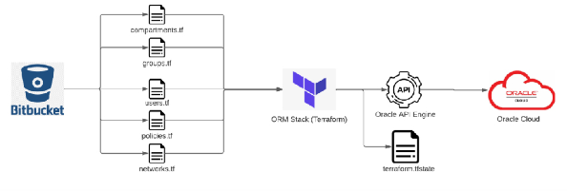

Create stack for the Tagging

Go to OCI Console Developer Services Resource Manager Stacks select the compartment Create Stack

My Configuration Folder Browse Select the “Tagging” folder that contains the terraform Upload

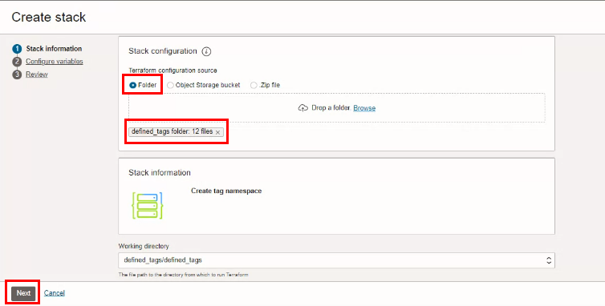

Click “NEXT”
Select the parameters as per the below screen,

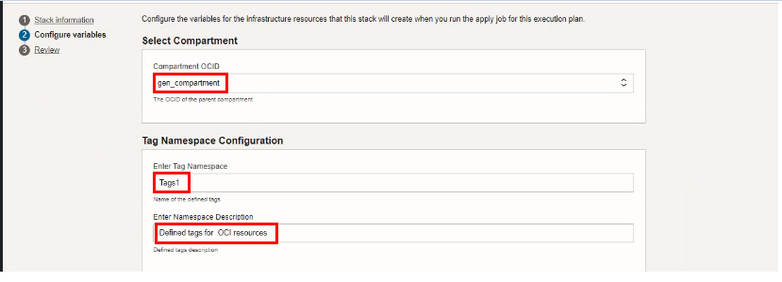

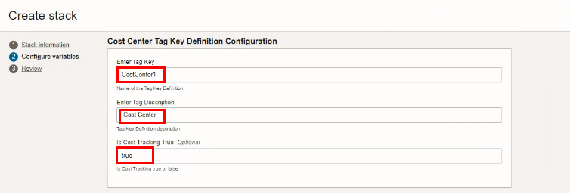

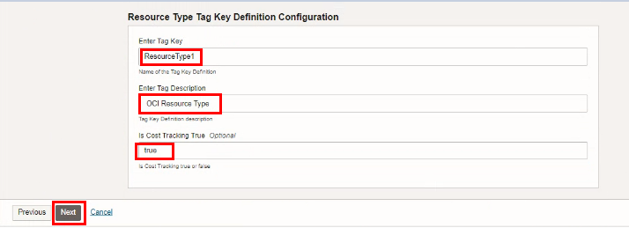

Click “NEXT”

Note: once the stack is created, the output is generated in the above specified compartment.
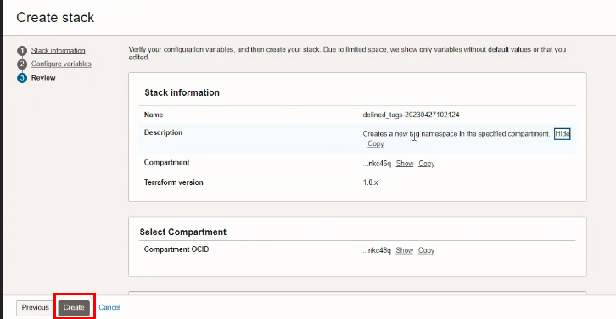

Click “CREATE

Plan the Job

Click the “Plan”

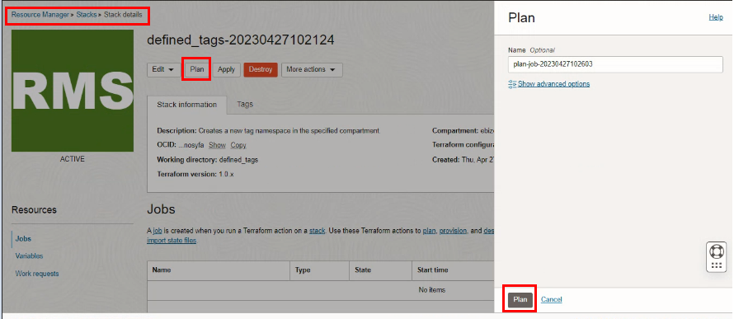

Verify the Plan is successful.

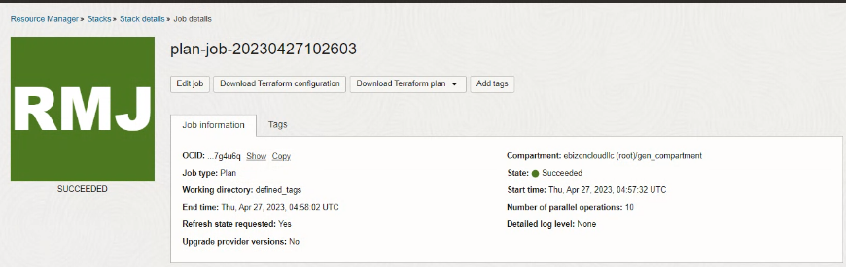

Apply the Job

Once the “plan” is success, now click “Apply”

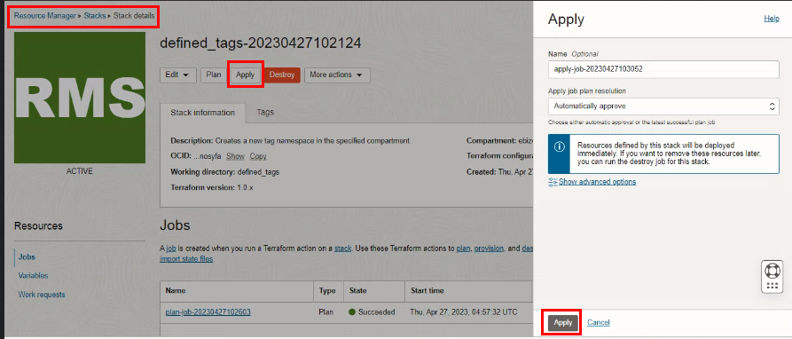

Verify the Apply is successful.

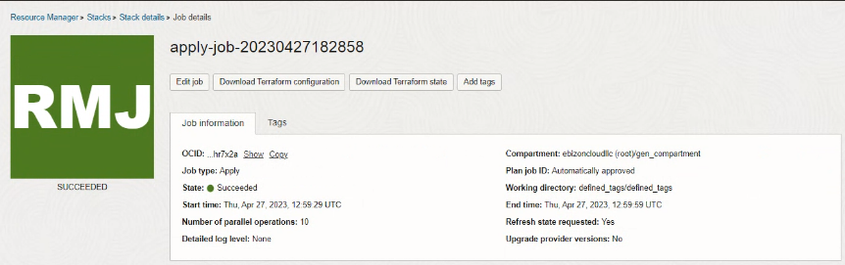

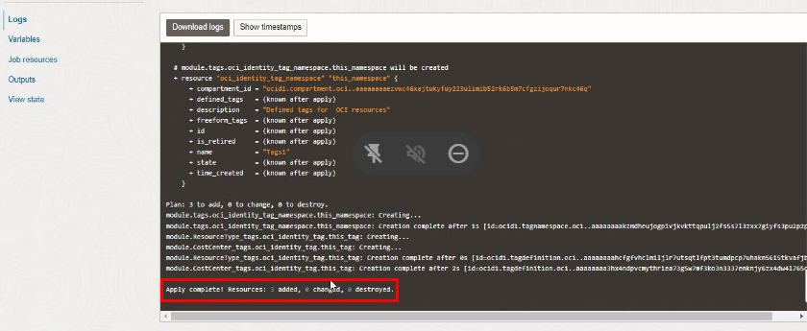

Verify in the Console

Go to OCI Console Goverance Tag Namespace Tag Namespace Details

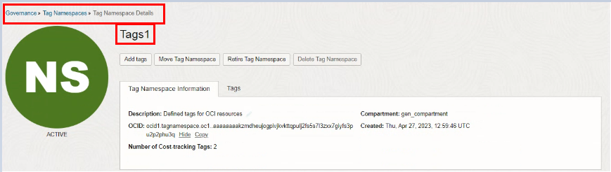

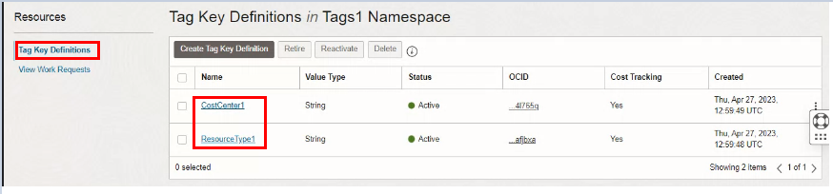

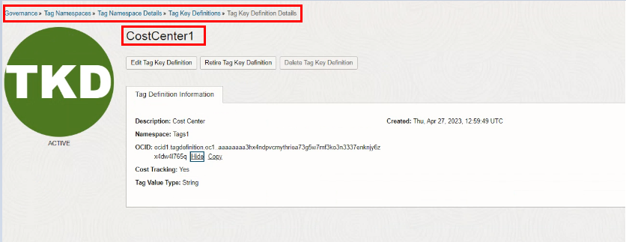

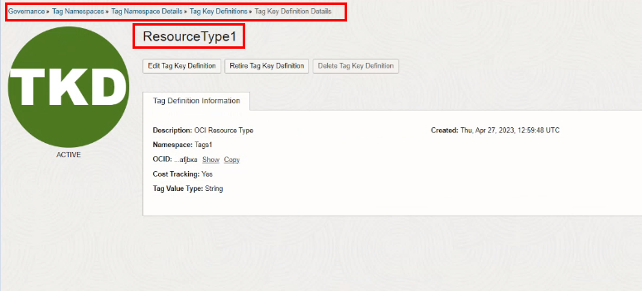

- Destroy the stack ( if required)

Create a destroy job in Resource Manager to release resources associated with a stack and clean up the tenancy. Once destroyed data cannot be recovered from resources.

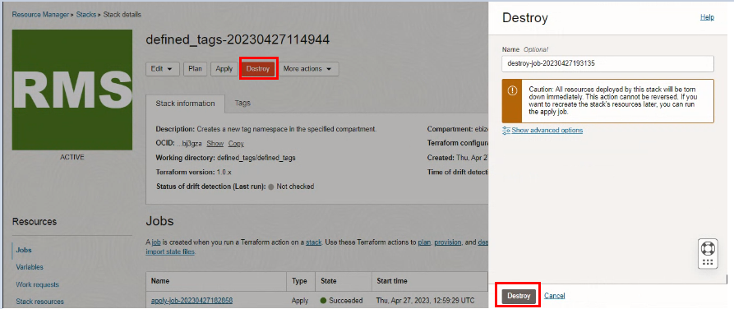

# END #

